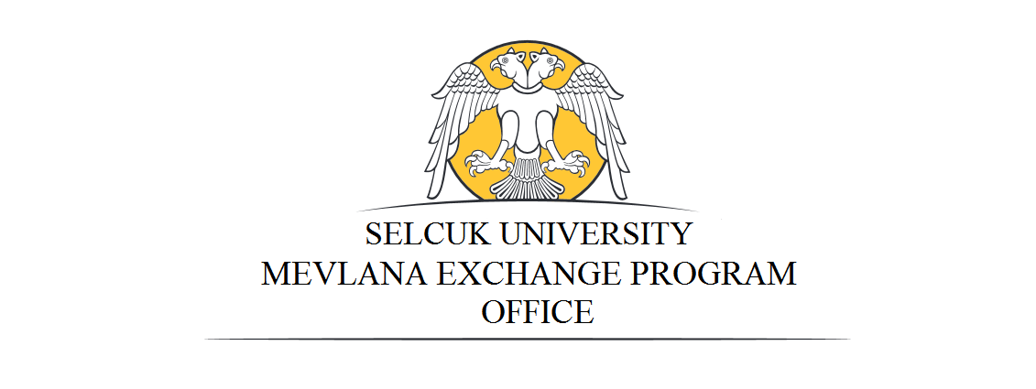
MEVLANA EXCHANGE PROGRAM ANNOUNCEMENT

General Information About Mevlana Exchange Program

- Mevlana Exchange Program is a program which aims the exchange of students and academic staff between the Turkish higher education institutions and higher education institutions of other countries without any geographical constraint.
- Students may study abroad for one (minimum) or two (maximum) terms and academic staff may lecture abroad from two weeks (minimum) to three months (maximum). Accordingly, students and academic staff from any country may benefit from this program being hosted by Turkish higher education institutions in order to study or lecture.
- Students do not pay any tuition fees to the host institution during the program, but they continue to pay the obligatory tuition fees to their home institutions. They do not pay any extra fee to the host institution within the scope of the exchange program.
- As the course(s) to be taken in the host institution are officially agreed to be counted in advance within the Learning Protocol, the students do not repeat any courses/semesters when they return.
- Mevlana Exchange Program students continue to take their other scholarships and grants in their home countries and they have to do registration in their home institutions.
- The scholarship amount to be paid to the Mevlana Exchange students is determined by Council of Higher Education Executive Board. FOR 2019-2020 ACADEMIC YEAR, THE AMOUNT OF SCHOLARSHIP FOR STUDENTS COMING TO TURKEY IS 1200 TL. PER MONTH.
- In terms of the scholarships that will be paid to the students, 80% of the scholarship amount is 3840 TL for four months. Payment will be done monthly. For the student's remaining grant payment, the ratio of total credits of the succeeded courses to the courses that the student is obliged to take as obligatory courses will be considered.
- Within the scope of Mevlana Exchange Program, travel allowance stated in the Travel Expense Law no.6245 may be paid to incoming and outgoing academic staff (MAXIMUM AMOUNT OF TRAVEL ALLOWANCE TO TURKEY IS 3500 TL, DAILY SUBSISTANCE IN TURKEY IS 50 TL for Professors, Associate Professors, Assistant Professors and 40 TL for other academic staff)
- For detailed information please visit: mevlana.yok.gov.tr

Conditions to Apply to Mevlana Exchange Program

Students:
- To be a student in the departments stated in the table below
- For undergraduate students, having minimum GPA 2,5/4,00
- For graduate students, having minimum GPA 3,00/4,00
- Have a good command of Turkish/English (the applicants may have Turkish/English proficiency test in their home country after application) (50% Turkish/English level+50% GPA will be taken into consideration for selection)
- Students studying at preparatory or first year of associate or bachelor’s degree and postgraduate and doctoral students studying at preparatory or scientific preparatory terms cannot benefit from this program for the first term that they have started the their primary study.

Academic Staff:
- HAVING A GOOD COMMAND OF TURKISH OR ENGLISH.
- Applicants who have not participated in this program before can be preferred.
- In the scope of mobility, academic activities of academic staff cannot be less than total six hours weekly. In hourly calculation of the activities performed by academic staff, courses are considered. If course hours do not complete six hours, academic activities like seminars, panels or conferences are evaluated in this context. Academic staff mobility plans which do not contain lectures shall not be considered within Mevlana Exchange Program and accepted for the Exchange. Research assistants cannot participate in the program as academic staff.

Required Documents for Application

Student and academic staff applications should be made ……… Office between February 05-28, 2019 with the documents written below:

Students:
- Transcript
- Language proficiency certificate/document
- Application Form (link)

Academic Staff:
- For English, language exam result certificate
- Academic Staff Application Form (link).
- CV and Academic Portfolio including all academic work

Universities and Quotas

Student Exchange
Name of the University | Country | Department | Degree |  |  | Duration
 |  |  | Bachelor | Master | PhD
Selcuk University | Turkey | English Translation | 5 | - | - | 2 semesters
 |  | English Language and Literature | 5 | - | - | 2 semesters
 |  | German Language and Literature | 5 | 5 | 5 | 2 semesters
 |  | French Language and Literature | 5 | 5 | 5 | 2 semesters

Faculty Member Exchange
Name of the University | Country | Department | Number of Academic Staff | Duration
Selcuk University | Turkey | English Translation | 5 | 3 Months
 |  | English Language and Literature | 5 | 3 Months
 |  | German Language and Literature | 5 | 3 Months
 |  | French Language and Literature | 5 | 3 Months

IMPORTANT:
- Because of the restrictions from Turkish Higher Council, we can only make exchanges on these departments for this year.
- After the first evaluation of Mevlana Exchange Program Applications by our office the information of applicants are sent to Turkish Council of Higher Education. The final decision about who will benefit from the program is given by Turkish Council of Higher Education.
- In accordance with the decision of the Turkish Higher Council’s Board of Directors from the meeting on 25.02.2015, the applicants cannot be Turkish citizen.

