 | UNIVERSITY |  |  | 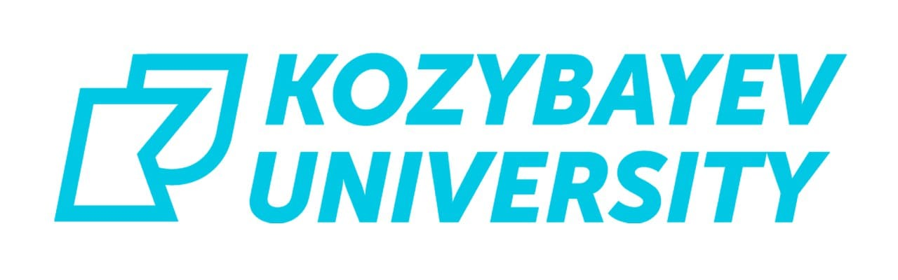

AGREEMENT FOR COOPERATION BETWEEN
M. KOZYBAYEV NORTH KAZAKHSTAN UNIVERSITY
AND
_________________________

№_______ ___________, _____ 2023

Party 1: M. Kozybayev North Kazakhstan University, represented by its
Chairman of the Executive Board – Rector, Yerlan Shulanov, acting on the basis of the Charter.

Party 2: ________, represented by its Rector Prof. Dr. _________, acting on the basis of the Charter, hereinafter referred to as «Parties», concluded the present Agreement about the following:
- Subject of the agreement
  - A subject of the present agreement is to establish the partnership (cooperation) in educational and scientific and research areas in the directions provided in item 1.2 of this agreement.
  - Within operation of the present Agreement the parties agree to assist each other in the following main directions:
    - joint organization and holding scientific events;
    - development and undertaking joint scientific research in the priority directions of the Parties;
    - exchange of scientific information, publications, educational and research achievements, educational curriculum, theses and reports in higher education institutions, within the countries of the agreement which are not contradicted by existing legislations, international law ratified by the countries;
    - joint edition of scientific, educational and methodical literature;
    - the organization of exchange of teachers and employees for lecturing, training sessions, a management of degree and dissertation researches;
    - the organization of exchange of top managers for the purpose of implementation of foreign managerial experience;
    - organization of the academic exchange of students, undergraduates and doctoral candidates;
    - organization of traineeships of teachers, undergraduates and doctoral candidates;
    - coordination of works on development of programs for educational process and creation of the database on working courses programs methodical providing, including using of distance learning technologies;
    - development of cooperative educational programs.
- Rights and obligations of parties
  - The parties have the right:
    - to initiate organization and holding research and scientific and methodical events;
    - to exchange experience on the questions which are a cooperation subject within this agreement;
    - to initiate involvement of other party to the organization and holding the joint events concerning questions of a cooperation within the present agreement;
    - to undertake joint actions to prevent, identify and suppress offenses in the area of intellectual property, patents, a know-how and to counteract such offenses;
    - to perform other works, interactions within the subject of the agreement.

  - The parties is committed to:
    - to provide timely to each other sufficient amount of the information which is available at their disposal concerning the organization and holding the joint events provided by Section 1 of the present agreement;
    - to consult each other on a grant basis in questions of the organization and holding the joint events arising from Section 1 of the present agreement;
    - to provide necessary material resources and conditions for holding joint events;
    - to inform beforehand each other on the arising problems in cooperating and to participate in search of ways of their decision;
    - to make proper efforts for ensuring implementation of all points of the present agreement;
    - to promote implementation of joint projects and programs in order, the size and the methods provided by the certain agreements signed in pursuance of the present agreement;
    - to keep the commercial, office and other secrets protected by legislations of the Parties;
    - not to use intellectual property items, a know-how for commercial purposes without consent of another party;
    - not to make known results of joint activities without the consent of both parties.

- Parties responsibilities
  - The parties are responsible for quality and timeliness of effective implementation of the present agreement.
  - In the implementation of cooperation under the present agreement the Parties are guided by provisions of the standard legal documents existing between the Governments of both countries in the areas of education, sciences and cultures.
  - The order of exchange of specialists, also financial provisions of cooperation shall be determined according to separate arrangements and conclusion of additional agreements. At the same time the Parties undertake to make the necessary effort to implement the articles of the present agreement.
  - Any changes and additions to the agreement are valid only if they are expressed in written form and signed by the authorized representatives of the parties. The signed agreement does not exclude the possibility of holding other events for cooperation that shall be agreed upon in writing.

- Term of agreement validity
  - The present agreement shall become effective and continued within five years from the date it is signed by both parties. The agreement is automatically prolonged for five years if any of the Parties did not notify on the intention to terminate the agreement in writing six months before the date of expiry of next duration of the agreement.
  - The present agreement is made in English in 2 copies and shall be kept in one copy for each of the parties.

- Other provisions of the agreement
  - This agreement does not provide any financial liabilities from the Parties.
  - Provisions of the present agreement can be changed by mutual consent of the Parties with the obligatory conclusion of the additional agreement which is an integral part of the present Agreement.
  - The disputes arise during the implementation of the present agreement are resolved by negotiations.
  - In case of unilaterally agreement cancelation the Party is obliged to notify in writing other party 1 (one) month before the termination for the purpose of timely settlement of all questions concerning observance of terms of the present agreement by the parties.

In witness thereof, the parties below have offered their signatures:

For and on behalf of  M. Kozybaуev North  Kazakhstan University  150000 Petropavlovsk,  Republic of Kazakhstan,  Pushkina st., 86  Tel.: +7 7152 493 352  Fax: +7 7152 493 342 | For and on behalf of
Date: | Date:
Signature: | Signature:
Ye. Shulanov

Chairman of the Executive
Board – Rector of M. Kozybayev
North Kazakhstan University

