

MINISTRY OF EDUCATION AND SCIENCE OF THE
REPUBLIC OF KAZAKHSTAN
Non-profit limited company "Manash Kozybayev North Kazakhstan University"

MINISTRY OF SCIENCE AND HIGHER EDUCATION OF THE RUSSIAN FEDERATION

Altai State University

Surgut State Pedagogical University
Siberian State University of Geosystems and Technologies

Information letter №1

Dear colleagues!

Non-profit limited company "Manash Kozybayev North Kazakhstan University" will hold the annual X international scientific and practical conference "Actual Problems of Mathematics and Natural Sciences" dedicated to the 75th anniversary of Associate Professor R.A. Akberdin on 4 February, 2022

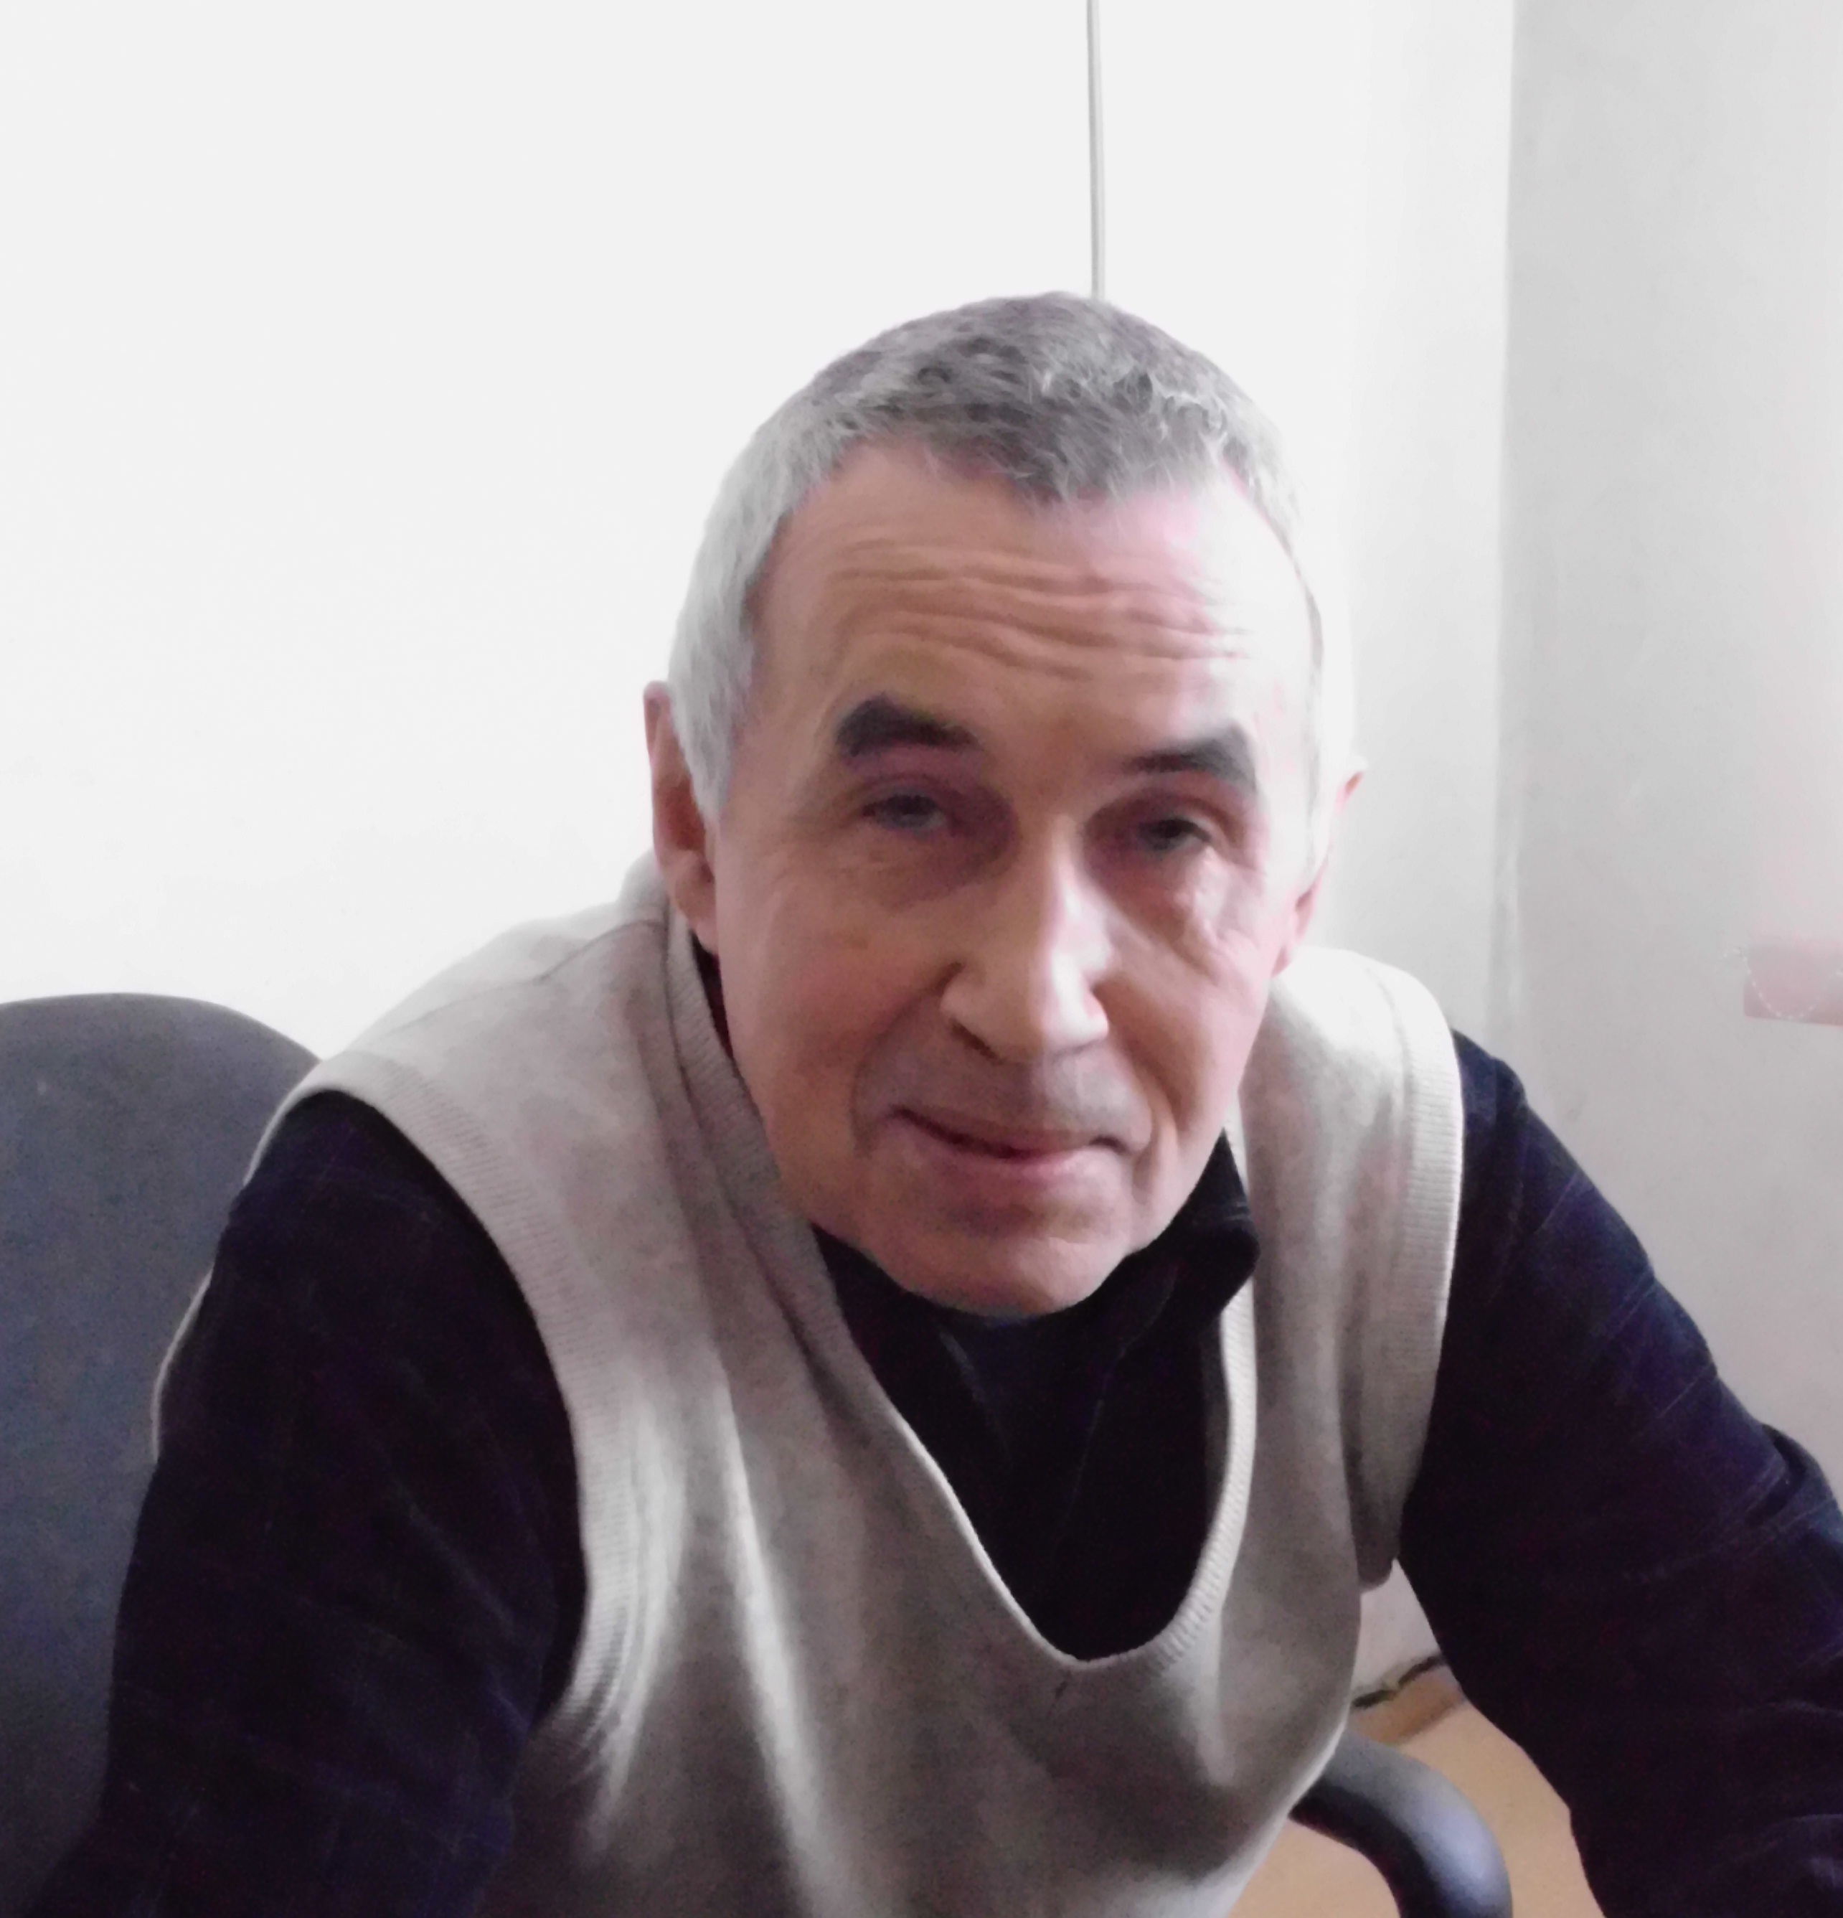

The conference is planned in the following directions:

№ | Section | e-mail | Contact person | Contact number
1 | Actual problems of science and education in the field of chemistry | bbegenova@mail.ru | Begenova Bakhyt Yestekenovna | +7 7152 49-40-42  (10-36)
2 | Ecological and geographical research | tabakaevaem@mail.ru | Tabakeeva Evgeniya Mikhailovna | +79029977743
3 | Modern problems of biological systems research | maosurgpu@gmail.com | Malkov Oleg Alekseevich | +79226547717
4 | Theory and methodology of teaching computer science, mathematics and physics: innovative approaches | sveta_lutsak@mail.ru | Lutsak Svetlana Mikhailovna | +7 (7152) 462796, (12-29)
5 | Mathematical modeling of sociotechnical systems | ogrigorenko2311@mail.ru | Grigorenko Olga Viktorovna | +79831254599 +73833443975

Working languages of the conference: Kazakh, Russian, English
The format of the conference is a ZOOM session

Conference languages: Kazakh, Russian, English.
To participate in the conference, you must submit an application, the text of the article (formatting in accordance with the attached requirements). There is no payment for participation in the conference (free). Papers must be submitted by January 20, 2022 in electronic form to the above email addresses.
The collection of conference materials will be published based on the materials of the conference.
The text of the article should be in A4 format, contain at least 6 pages, in the Word editor, font size 12 (for bibliography, font size 10), spacing 1.0, font “Times New Roman”, alignment to the width of the page, margins on all sides 25 mm with indication of Universal decimal classification. The originality of articles is at least 50%.
The collection of conference materials will be typed by direct copying. In this regard, we draw your attention to the need to submit scientific articles in a carefully edited form, in compliance with all the above requirements. For authors who do not have an academic degree, attach a review of a doctor (PhD) or candidate of sciences to articles.
Materials submitted later than the specified period or not formatted in accordance with the requirements are not considered and will not be returned to the authors.
Contact information of the organizing committee:
Secretary of the organizing committee: Bazarbayeva Saule Mukhametkalievna, Deputy Dean of the FMNS for scientific work and quality management of the NPLC "M. Kozybayev NKU", e-mail: ssdarina12@mail.ru ; tel.: +77714773470 (WhatsApp).
Organizing Committee

UDK 691.33

THE LEGACY OF M. ZHUMABAEV AND SPIRITUALITY

Abileva B.T., Syzdykova D.S.
(M. Kozybayev NKU)

The main text of the article.

Literature:
1. Vilkov V.S., Gaidin S.G., Gubin S.V., Zuban I.A., Krasnikov A.V. Results of monitoring of goose-like birds in the North Kazakhstan region in the spring of 2011//Materials of the international scientific and practical conference "Independent Kazakhstan and the scientific heritage of Academician M. Kozybayev". - Petropavlovsk, 2011. - pp. 54-59.
2. Bayekenova M.K. et al. Environmental problems of the agricultural sector of the economy of Kazakhstan //Scientific and applied research in the field of environmental protection. - Almaty, 2006. - pp. 59-67.
3. "Environmental protection and sustainable development of Kazakhstan". Statistical collection of ARKS Astana, 2009.

Application for participation in the conference

Surname_______________________ First name___________ Patronymic
Organization, position
Scientific Degree, rank
Address (full)
Author’s phone (home, work)
Author’s e-mail
The theme of the report
Session (note the number and the name)
Conference fee paid (No. of payment orders, upon arrival)______________________________
Need for booking a hotel room ___________________________________________________
Date________________________________________ Signature

Detailed information about the organization of zoom sessions will be provided in information letter No. 2!

