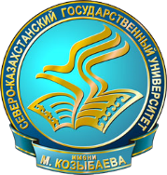
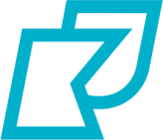
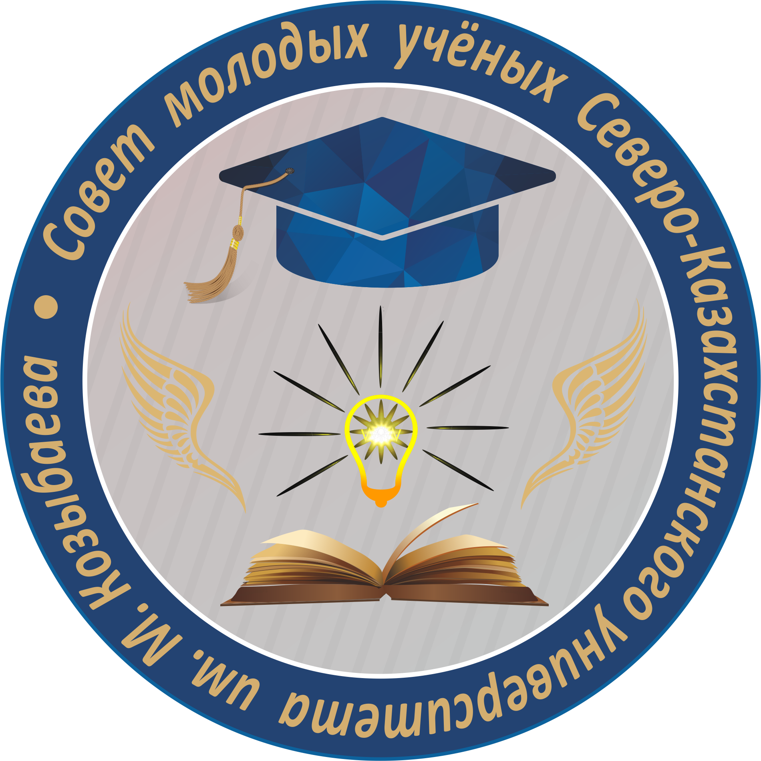
MINISTRY OF EDUCATION AND SCIENCE OF THE REPUBLIC OF KAZAKHSTAN
M.KOZYBAYEV
NORTH KAZAKHSTAN UNIVERSITY

INFORMATION LETTER
Dear students and teachers!
Kozybayev University Council of Young Scientists organizes an annual competition of exhibitions of scientific achievements among student scientific societies (SSS) of all M.Kozybayev NKU faculties.
The purpose of the competition: monitoring of the SSS faculties research activities in order to identify the most promising student scientific achievements.
Competition planning: The chairman or head of the SSS is to fill in an electronic application form to participate in the competition. The application must be sent by February 13, 2023 to the email address of the Council of Young Scientists smu@ku.edu.kz The application form must contain information about the faculty and department; the name of the SSS; the date and time of the presentation of the achievements of the SSS; the place of presentation (auditorium, building), the participants presenting the work (according to the composition of the annual plan of the SSS), contact information of the chairman or head. The presentation is to be delivered by 2 participants only. When making an application, it is necessary to specify the planned presentation date from February 15 to February 28, 2023. In case of coincidence of the presentation time and date of two or more SSS, the competition committee will contact the chairpersons / supervisors and adjust the time and day of the presentation.
The presentation will be held in an off-line format in the auditorium specified in the application of each SSS.
Competition procedure: participants of each SSS will showcase scientific achievements over 2022 according to the directions of research. The exhibition may include presentation slides, prints of student publications, certificates, models, devices, drawings, computer programs and other products of student scientific activities. The time allotted for the exhibition of scientific achievements of each SSS is 20-30 minutes.
Criteria for evaluating the exhibition of scientific achievements:
- Scientific component;
- approbation of the results of scientific activity;
- practical application of the results;
- autonomy of student research;
- relevance within the region and the Republic of Kazakhstan;
- exhibition design;
- SSS work continuity between courses;
- the need to finance the current SSS scientific projects.
The results of the competition will be announced from March 1 to March 6, 2023. According to the results of the competition, the three best University’s SSS will be allocated funds for further scientific research. All competition participants will be awarded with certificates.
For all additional questions, contact tel. 87055698255 Pavel Anatolyevich Petrov, Chairman of the Council of Young Scientists.

Council of Young Scientists
M. Kozybayev NKU

Example of an application form for participants in the competition

To P.A. Petrov,
Chairman of the
Council of Young Scientists
of M.Kozybayev NKU

Application

I am writing to request your permission to include SSS “Name of Faculty” “Name of Department” to participate in the annual competition of exhibitions of scientific achievements Date of the exhibition: Day and time of the presentation. Place of the exhibition: Building, auditorium
Students as SSS members, participating in the competition:

№ п.п. | Full name | Group
1
2

Signature Full name of the chairman/ supervisor, e-mail, telephone number

